1. INTRODUCTION

  - Project Overview
AutoSage is an AI-powered application that provides detailed information about two-wheeler and four-wheeler vehicles using image-based analysis. The system uses Google’s Gemini Flash model to analyze vehicle images and generate structured details such as brand, model, mileage, price range, and resale value. AutoSage simplifies the vehicle selection process by delivering real-time insights through an easy-to-use Streamlit interface.
- Scenario 1: Buying a New Motorcycle
Sarah uses AutoSage to compare motorcycle specifications, features, and prices within her budget, helping her make an informed purchase decision.
- Scenario 2: Vehicle Maintenance Tips
AutoSage provides seasonal maintenance suggestions, such as checking tire pressure and battery health, to help users maintain vehicle safety and performance.
- Scenario 3: Finding Eco-Friendly Vehicles
Emma uses AutoSage to explore electric and hybrid vehicles by understanding efficiency, environmental impact, and available incentives.
1.2 Objectives
The primary purpose of the AutoSage project is to develop an intelligent Generative AI–based system that can automatically analyse vehicle images and provide detailed vehicle information. It aims to assist users such as vehicle buyers, owners, and eco-conscious consumers by enabling quick and accurate understanding of two-wheeler and four-wheeler details reducing manual research and improving decision-making efficiency.
Key Objectives:
- To analyse vehicle images using a multimodal Generative AI model.
- To generate structured vehicle details such as brand, model, mileage, price and resale value.
- To build a simple user-friendly web application using Streamlit.
- To enable real-time vehicle comparison and information retrieval for practical use cases.

2. PROJECT INITIALIZATION AND PLANNING PHASE
2.1 Defining Problem Statement
Customers who want to buy or compare two-wheelers and four-wheelers often find it difficult to get clear and complete vehicle information in one place. They try to understand details such as brand, model, mileage, features, price, and resale value, but the information is scattered across multiple websites. Most platforms require manual searching and reading long, complex specifications, which is time-consuming and confusing. Existing systems do not use image-based AI to provide instant and structured insights. This makes customers feel frustrated, unsure, and less confident while making vehicle-related decisions.
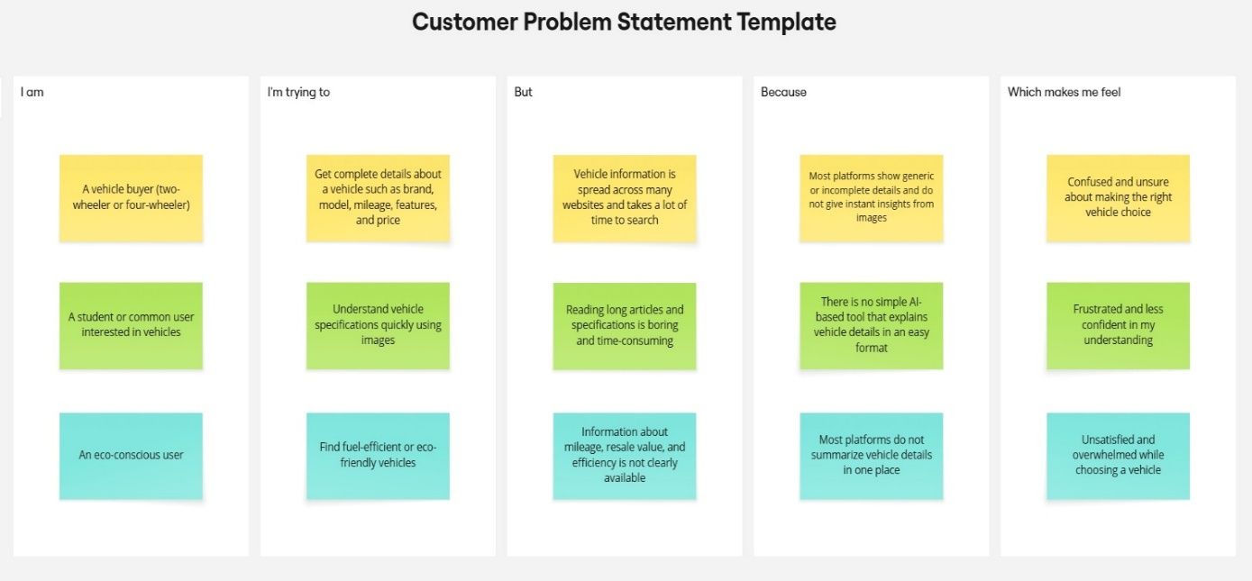

Problem  Statement (PS) | I am  (Customer) | I’m trying to | But | Because | Which makes me feel
PS-1 | A vehicle buyer | Understand vehicle details before buying a bike or car | Searching for vehicle information takes too much time | Vehicle details are spread across many websites and need manual comparison | Confused and unsure about choosing right vehicle
PS-2 | A student or general user | Identify and understand a vehicle using its image | Reading ling specifications and reviews is difficult | Most platforms do not support image-based vehicle analysis | Frustrated and less confident
PS-3 | An eco-conscious user | Find fuel-efficiency or eco-friendly vehicles | It is hard to get clear information about mileage and efficiency | Vehicle information is not summarized in one place | Dissatisfied and overwhelmed

2.2 Project Proposal (Proposed Solution)
Project Overview
Objective | The main objective of the AutoSage project is to build an application that gives vehicle details such as brand, model, mileage, price, and resale value by analyzing vehicle images using Gemini Flash.
Scope | The project allows users to upload images of two-wheelers and four-wheelers and receive vehicle information through an AI model. The project focuses only on providing information and does not include vehicle booking or payment features.
Problem Statement
Description | Users find it difficult to collect complete vehicle information from one place. Vehicle details are available on many websites, which makes searching and comparing vehicles slow and confusing.
Impact | This problem affects users by wasting time and making it harder to choose the right vehicle. A simple and quick solution is needed to reduce confusion.
Proposed Solution
Approach | AutoSage uses the Gemini Flash AI model to analyze vehicle images. A Streamlit web application is used to upload images and show vehicle details instantly.
Key Features | Upload vehicle images  AI-based vehicle analysis  Clear and structured output  Easy-to-use interface  Secure API key usage

Resource Requirements
Resource Type | Description | Specification/Allocation
Hardware
Computing Resources | Laptop or Desktop | Standard System
Memory | RAM | Minimum 8 GB RAM
Storage | Disk space | 10 – 20 GB
Software
Frameworks | Python frameworks | Streamlit
Libraries | Additional Python libraries | Google-generativeai, python-dotenv, Pillow
Development Environment | IDE, version control | VS Code, Github
Data
Data | User-uploaded vehicle images | Small to medium-sized images (JPG, JPEG, PNG)

2.3 Initial Project Planning
Product Backlog, Sprint Schedule, and Estimation (4 Marks)
The following table represents the product backlog and sprint-wise planning for the AutoSage project.
Sprint | Functional Requirement (Epic) | User Story Number | User Story / Task | Story Points | Priority | Team Members | Sprint Start Date | Sprint End Date (Planned)
Sprint-1 | User Interface Setup | USN-1 | As a user, I want a Streamlit-based interface to upload vehicle images easily. | 2 | High | All Team members | 28 January 2026 | 31 January 2026
Sprint-1 | Image Upload Validation | USN-2 | As a user, I want the system to validate the uploaded image format (jpg, jpeg, png). | 1 | High | All Team members | 28 January 2026 | 31 January 2026
Sprint-2 | AI Model Integration | USN-3 | As a user, I want the system to analyze vehicle images using the Gemini Flash model. | 3 | High | All Team members | 02 February 2026 | 09 February 2026
Sprint-2 | Prompt Engineering | USN-4 |  | 2 | High | All Team members | 02 February 2026 | 09 February 2026
  As a user, I want the system to generate structured vehicle details like brand, mileage, and price.
Sprint-3 | Output Display | USN-5 | As a user, I want to view the generated vehicle details clearly on the screen. | 2 | High | All Team members | 12 February 2026 | 18 February 2026
Sprint-3 | Deployment | USN-6 | As a user, I want the AutoSage application to be deployed and accessible through the browser. | 2 | Medium | All Team members | 12 February 2026 | 18 February 2026

3. DATA COLLECTION AND PREPROCESSING PHASE
3.1 Data Collection Plan and Raw Data Sources Identified
Data Collection Plan Template
Section | Description
Project Overview | AutoSage is an AI-based application that analyzes vehicle images to provide structured vehicle information such as brand, model, mileage, price, and resale value.
Data Collection Plan | Data is collected directly from users in the form of uploaded vehicle images through the Streamlit web interface.
Raw Data Sources Identified | The raw data source consists of images of two-wheelers and four-wheelers uploaded by users during application usage.

Raw Data Sources Template
Source Name | Description | Location/URL | Format | Size | Access Permissions
User-uploaded vehicle images | Images of two-wheelers and four-wheelers uploaded by users | Local system via Streamlit app | JPG, JPEG, PNG | Small to Medium | Private(User provided)

3.2 Data Quality Report
Data Quality Report Template

Data Source | Data Quality Issue | Severity | Resolution Plan
User-uploaded vehicle images | Images may be blurry or low resolution | Moderate | Prompt users to upload clear images and rely on Gemini Flash’s robustness
User- uploaded vehicle images | Different image sizes and orientations | Low | Images are resized automatically during display and preprocessing
User-uploaded vehicle images | Incorrect or unrelated images | Moderate | Application validates image format and processes only supported formats.

3.3 Data Preprocessing
Preprocessing Template
In the AutoSage project, vehicle images uploaded by users are preprocessed before analysis. The images are resized and normalized to maintain consistency. Basic noise handling and color processing are applied to improve image clarity. The complete image is used without heavy modifications to retain important vehicle details. These preprocessing steps help the AI model generate accurate and reliable vehicle information.

Section | Description
Data Overview | The data used in this project consists of vehicle images uploaded by users through the Streamlit interface. These images include two-wheelers and four-wheelers. No external dataset is used.
Image Validation | Uploaded images are checked to ensure they are in supported formats such as JPG, JPEG, or PNG before processing.
Image Handling | The uploaded image is loaded using the Pillow library and passed directly to the Gemini Flash model for analysis.
Prompt Formatting | A structured prompt is combined with the uploaded image to guide the AI model in generating organized vehicle details.
Model Input Processing | The image and prompt are sent to the Gemini Flash model, which internally handles feature extraction and image understanding.
Data Preprocessing Code:
Loading Data | Vehicle images are collected directly from users through the Streamlit file uploader.
Input Validation | The application ensures an image is uploaded before sending the request to the AI model.
Prompt Creation | The validated image is paired with a predefined automobile-specific prompt.
Model Invocation | The combined image and prompt are sent to the Gemini 2.5 Flash model for content generation.
Output Handling | The generated vehicle details are received from the model and displayed clearly on the Streamlit interface.

4. MODEL DEVELOPMENT PHASE
4.1 Model Selection Report
Model Selection Report
In the AutoSage project, the focus is on selecting a pre-trained multimodal generative AI model capable of analyzing vehicle images and generating structured vehicle information in real time. Unlike traditional deep learning projects that require training convolutional neural networks (CNNs), this application leverages an existing large-scale generative model.
The model is selected based on its ability to handle image and text inputs, fast response time, ease of integration, and suitability for real-time vehicle information generation.

Model Selection Report:
Model | Description
Gemini 2.5 Flash  (models/gemini-2.5-flash) | A pre-trained multimodal generative AI model designed for fast and efficient processing of image and text inputs. It provides real-time analysis of vehicle images and generates structured information such as brand, model, mileage, price, and resale value. Its low latency and high-quality responses make it ideal for the AutoSage application.

4.2 Initial Model Training Code, Model Validation and Evaluation Report
In this project, no custom model training is performed. Instead, a pre-trained generative AI model is integrated and used for recipe blog generation. The focus of this phase is on model selection, configuration, prompt design, and output evaluation, rather than training from scratch.
Initial Model Training Code (5 marks):
Model Selection and Initialization
The Gemini Flash (models/gemini-2.5-flash) model is selected for the AutoSage project due to its ability to process both image and text inputs, fast response time, and suitability for real-time applications.
The model is accessed using the Google GenAI SDK, and it is initialized securely using an API key stored in environment variables. The application sends a vehicle image along with a structured prompt to the model, which generates vehicle-related insights.
Since the model is already pre-trained, no training loop, loss function, or optimizer is required.
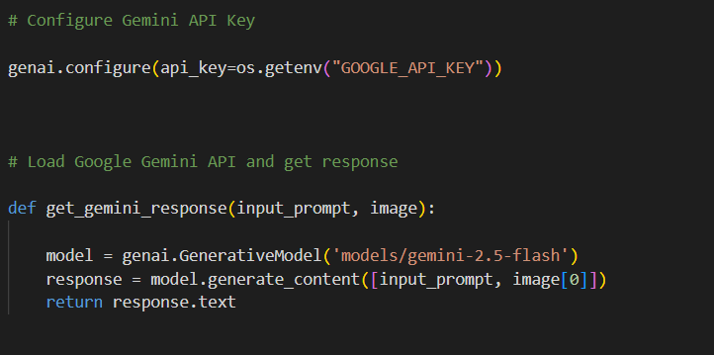

Model Validation and Evaluation Report (5 marks):
Model | Summary | Training and Validation Performance Metrics
Gemini 2.5-flash | Pre-trained generative language model optimized for fast text generation | Pre-trained multimodal generative AI model capable of understanding images and generating structured text responses

5. MODEL OPTIMIZATION AND TUNING PHASE
5.1 Tuning Documentation
Model Optimization and Tuning Phase
The Model Optimization and Tuning Phase in the AutoSage project focuses on improving the quality, clarity, and reliability of AI-generated vehicle information. Since AutoSage uses a pre-trained Generative AI model, optimization is achieved through prompt refinement, response structuring, and inference configuration rather than traditional neural network training.

Hyperparameter Tuning Documentation (8 Marks):
Model | Tuned Hyperparameters
Gemini 2.5 Flash | Temperature: Set to a balanced value to ensure the generated vehicle details are clear and factual without unnecessary creativity.  Top-p: Used to control token selection so that the responses remain relevant and consistent.  Top-k: Helps limit token choices to avoid irrelevant or incorrect vehicle information.  Max Output Tokens: Configured to ensure all required vehicle details such as brand, mileage, price, and resale value are generated completely.  Response Format: Set to structured plain text for easy display in the Streamlit user interface.

5.2 Final Model Selection Justification
Final Model | Reasoning
Gemini 2.5 Flash  (models/gemini-2.5-flash) | The Gemini 2.5 Flash model is selected due to its fast response time, strong multimodal capabilities, and efficient handling of image and text inputs. It provides accurate and structured vehicle information in real time and integrates seamlessly with the Streamlit application, making it well-suited for the AutoSage project.

6. RESULTS

6.1 Output Screenshots
The complete execution of the AutoSage application is shown in the images step by step as shown below.

Step 1: Run the app.py code using streamlit run app.py and you will get a link in terminal http://localhost:8501 which opens automatically in the browser.

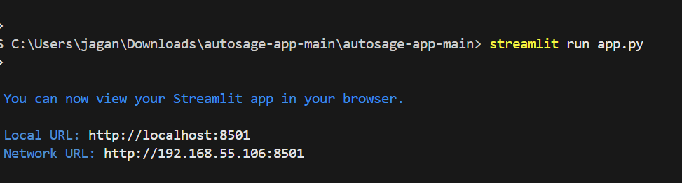

Fig 6.1.1: Code running in Terminal

Step 2: The link automatically opens to display the application.

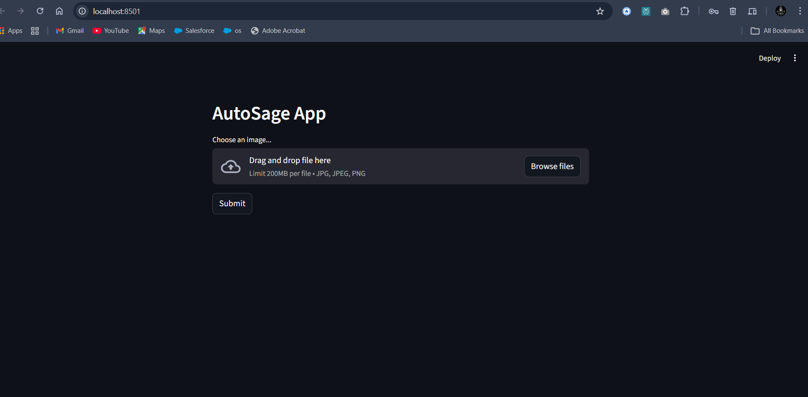

Fig 6.1.2: AutoSage App Page

Step 3: Click on Browse Files option to predict the vehicle details.

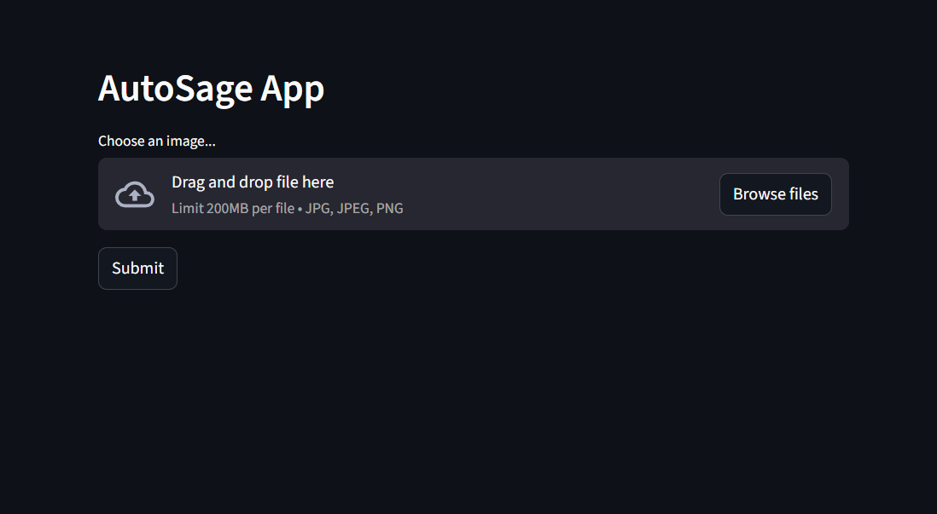
Fig 6.1.3: Prediction Page of AutoSage App

Step 4: Click on choose file option to choose the images that need to predict.

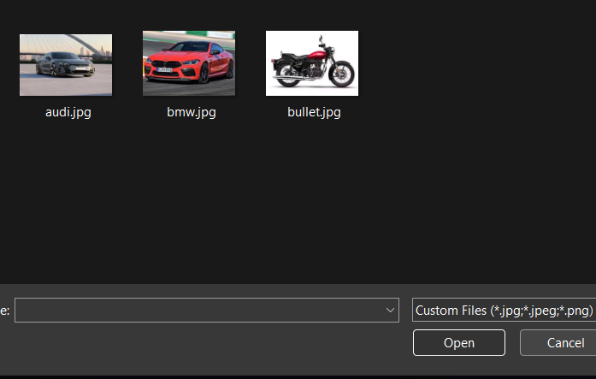
Fig 6.1.4: Window to choose image for prediction

Select any image for prediction and click on Open.

Step 5: The image loads into the application.

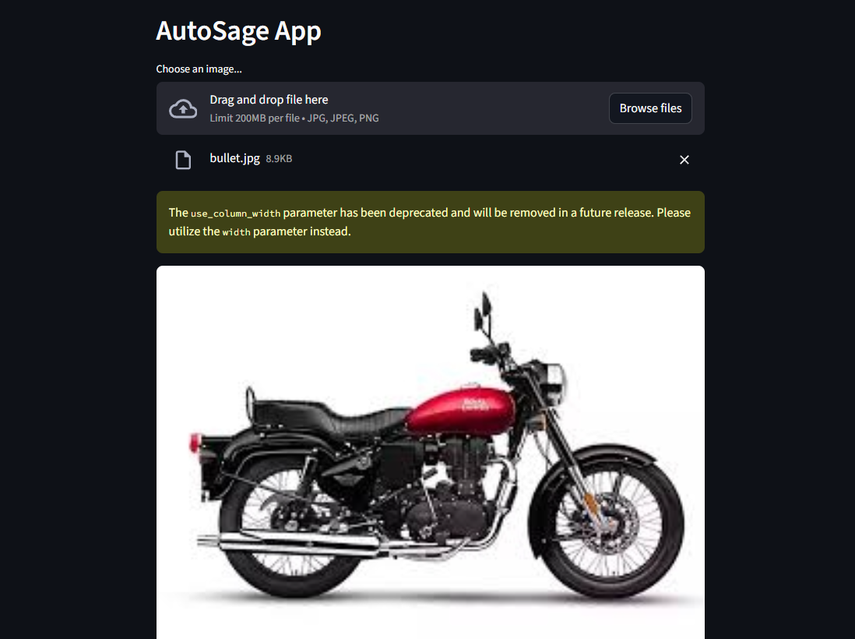

Fig 6.1.5: Image loads into the app.

Step 6: Now click on the Submit button to detect the type of vehicle and its details.

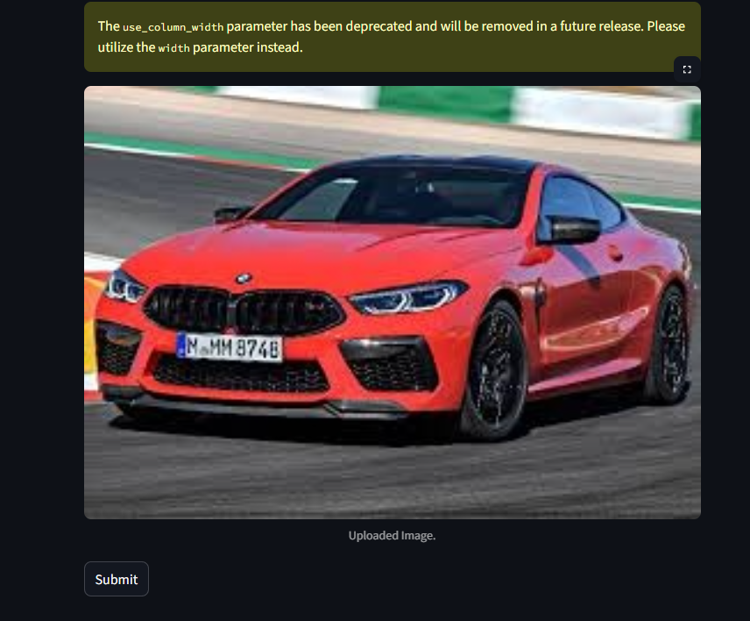

Fig 6.1.6: Click on submit to predict

Step 7: The model then predicts the type of the vehicle and provides its specifications as given below.


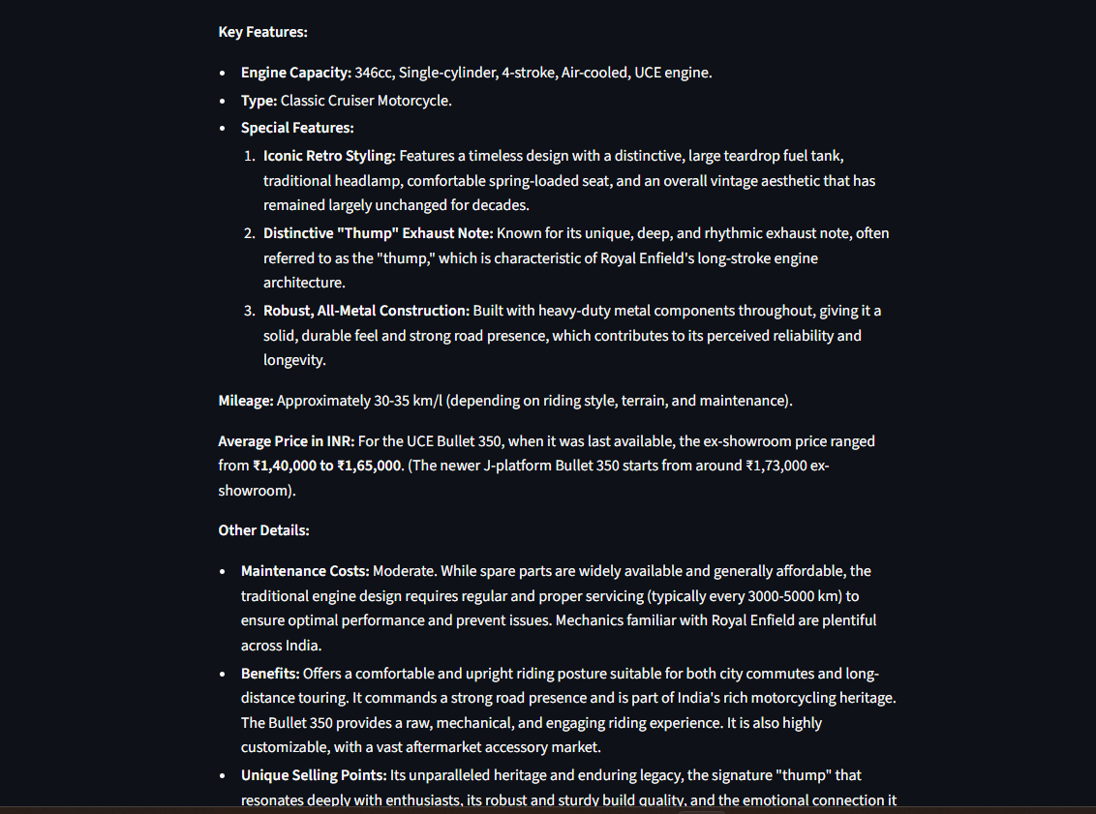
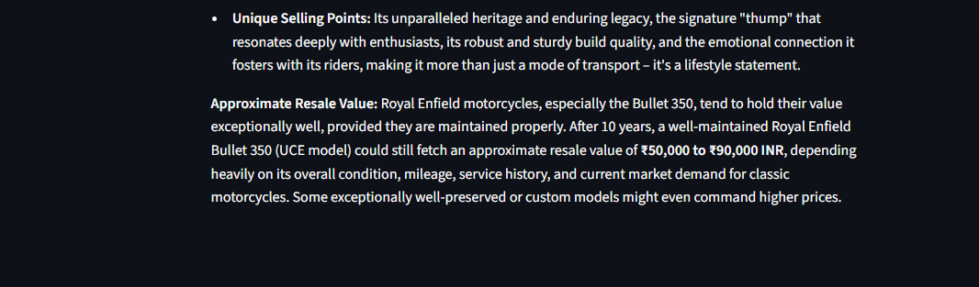
Fig 6.1.7: Output (Details of the vechicle)
7. ADVANTAGES & DISADVANTAGES
7.1 Advantages of AutoSage Project
Advantage | Description
Automated Vehicle Analysis | Automatically analyzes vehicle images and generates detailed information, reducing the need for manual research.
Fast & Real-Time Results | Gemini Flash provides quick responses, allowing users to get vehicle details instantly.
User-Friendly Interface | The Streamlit-based web application allows users to upload images and view results easily without technical knowledge.
Multimodal AI Capability | Supports both image and text input, enabling accurate understanding of vehicle visuals and descriptions.
Scalability | The application can be extended to support more vehicle types, brands, and additional features in the future.
Data-Driven Decisions | Helps users make informed vehicle purchase and maintenance decisions based on structured AI-generated insights.
Cost & Time Saving | Eliminates the need to visit multiple websites or consult experts, saving time and effort for users.
Table 7.1: Advantages
7.2 Disadvantages / Limitations
Disadvantage | Description
Dependence on Image Quality | Low-quality or unclear vehicle images may reduce the accuracy of generated information.
Internet Dependency | The application requires an active internet connection to access the Gemini API.
API Usage Limits | Free-tier API usage is limited and may cause temporary restrictions under heavy usage.
No Physical Inspection | The system cannot detect hidden mechanical issues or internal vehicle defects.
Requires API Key Security | Improper handling of API keys may lead to security or quota issues.
Table 7.2: Disadvantages
8. CONCLUSION
The AutoSage project successfully demonstrates the use of Generative AI to analyze vehicle images and generate structured vehicle information using the Gemini Flash model. By integrating a user-friendly Streamlit interface, the system allows users to upload vehicle images and instantly receive details such as brand, model, features, mileage, price range, and resale value. This approach reduces manual research, saves time, and supports informed decision-making for vehicle buyers and owners. Overall, AutoSage highlights the practical application of AI in the automotive domain and provides a strong foundation for future enhancements.

9. FUTURE SCOPE
The AutoSage project can be further enhanced by integrating additional features and technologies. In the future, the application can support video-based vehicle analysis to provide more accurate insights. Integration with official vehicle databases can improve data accuracy and reliability. The system can also be extended to include a mobile application for wider accessibility. Additionally, multi-language support and cloud deployment can be implemented to improve scalability and reach a larger user base.

10. APPENDIX
10.1 Source Code
The complete source code for the AutoSage project is implemented using Python, Streamlit, and the Google Gemini API. The code includes modules for image upload, AI model integration, prompt handling, and output display.

10.2 GitHub & Project Demo Link
The source code and project demonstration video are hosted on GitHub. The repository contains all required files, including the application code, documentation, and setup instructions.
- GitHub Repository: https://github.com/Jaganmohansai/AutoSage-App-Using-Gemini-Flash/tree/main
- Project Demo Video: https://drive.google.com/file/d/1-4Oe0MTIwW-K9ai_k_p4rS-dh4JRyN-L/view?usp=sharing

